1920 Replicas – 1000 Partitions- 100 Topic

3 Producer 2 Consumer (Default Rebalancing)

Load Test Duration – 15.30-16.10 (Rebalance Triggered at 16.02)

Load Test Duration – 22.38-23-15 (Rebalance Triggered at 23.09)

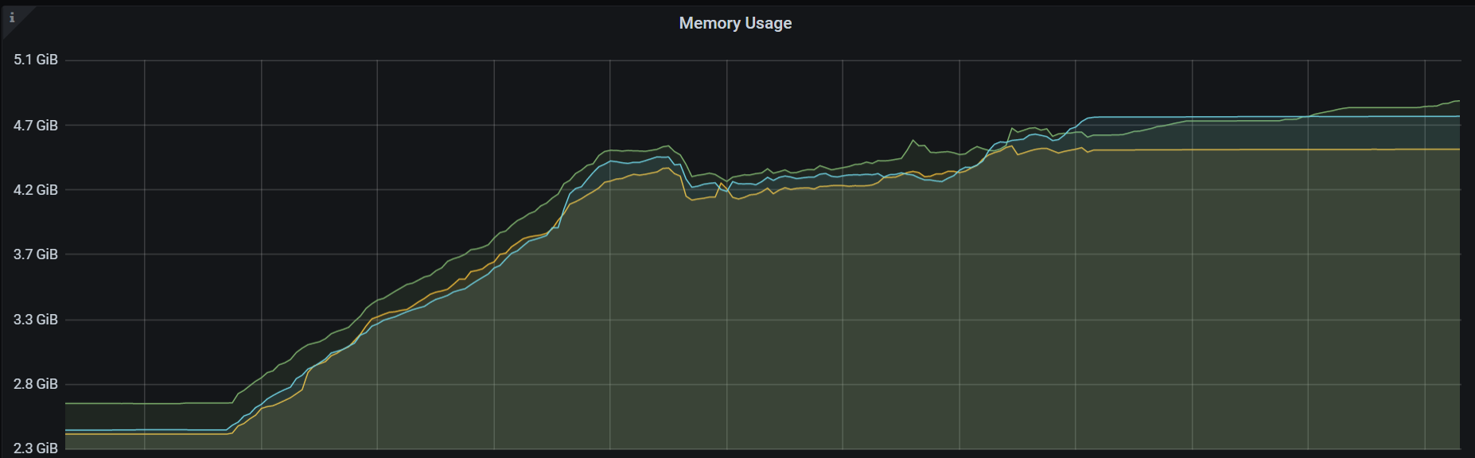

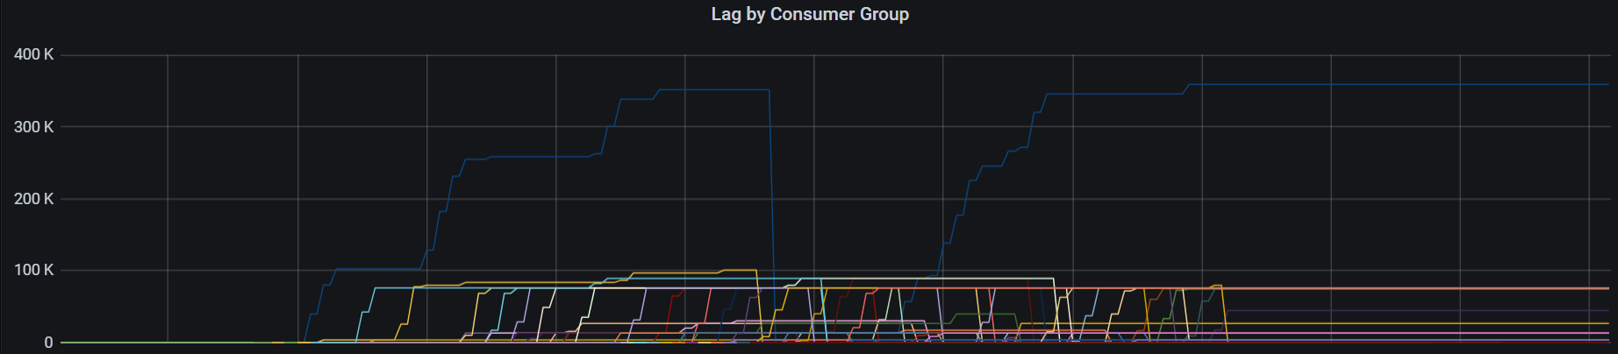

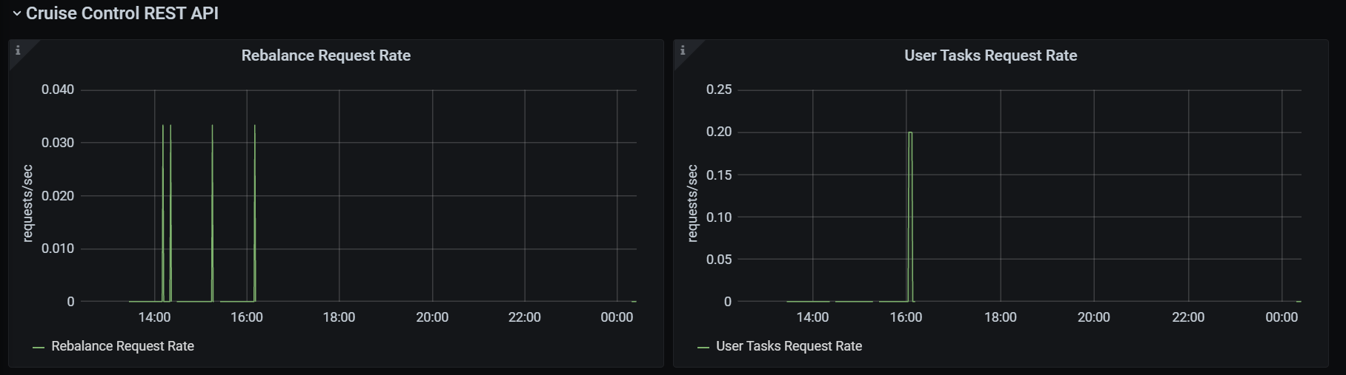

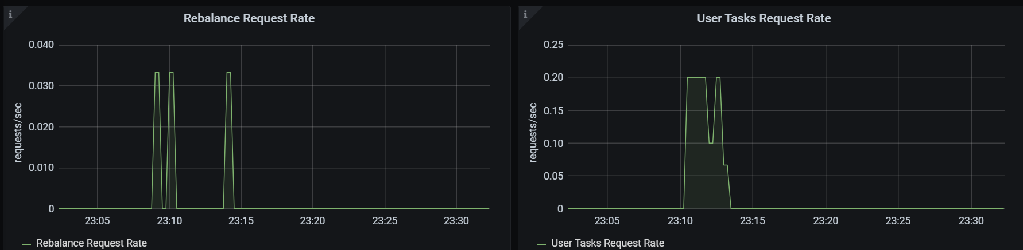

Consumer Msg Lag

64

68.4